I would like to contest for the position of Chair, PR Committee within the association. I am very much aligned with the goals and focus of the alumni association and I would like to use the skills gained in my time as a head of several committees in USIU to help alumni projects such as yours reach its objectives. My Diploma in Public Relations is also a huge advantage to this role.

I have worked with the fund raising committee to drive their annual Fun Run Campaign, my first volunteering assignment on campus was actually at the Alumni fundraiser when they were unveiling the new Mama Africa. Giving back to the institution is vital to the committee and I would love to be part of such an association.

I have also spearheaded HeForShe as the Chairlady for two consecutive terms and moved on to be part of the USIU-Africa Culture Week 2017, the Black History Committee and not least, volunteering with UNEP for the Blue Economy and UNCTAD on a PR & Communications capacity. I believe that my extensive experience in spearheading PR related events and activities give me a clear understanding of this role.

Warm Regards,

Halima

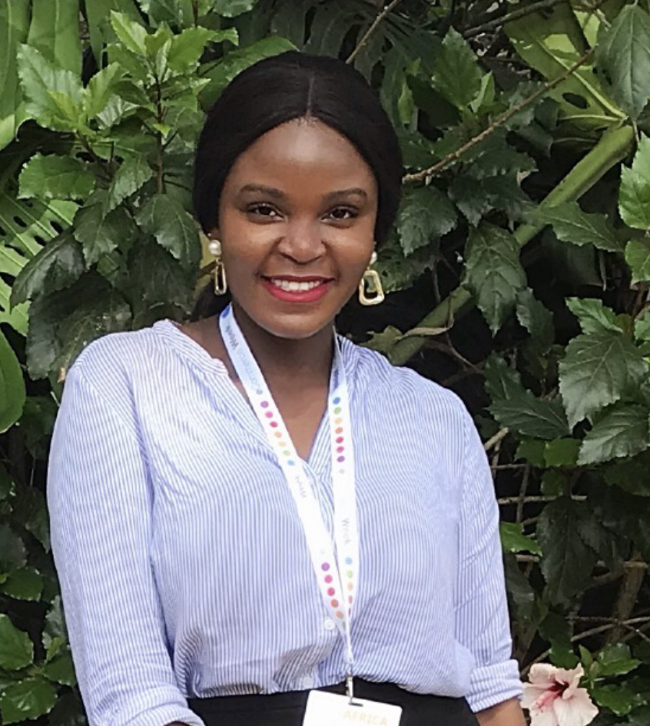
Name: Halima Kimalo Ramadhan
Graduation Year: 2018
Program/Major: e.g. MA International Relations
Position vied for: Chairperson Public Relations

